**Sourcetree code submission**

1. First switch to the branch where the code needs to be modified:

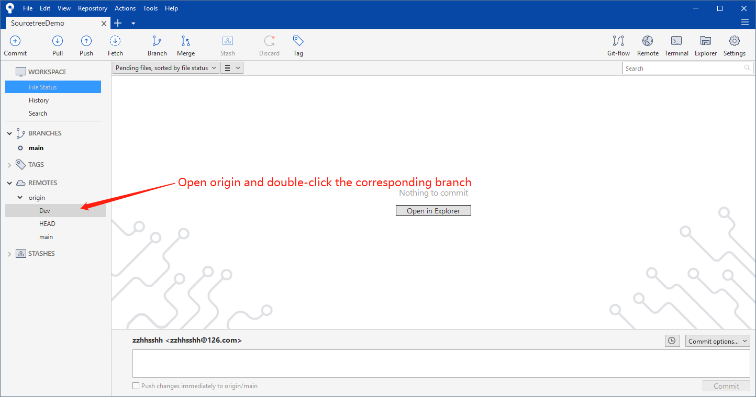

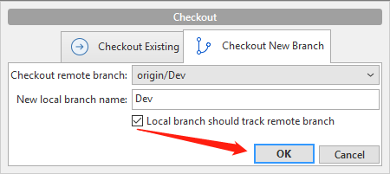

Note: The local Dev branch is automatically created

2. Submit the modified code to the staging area:

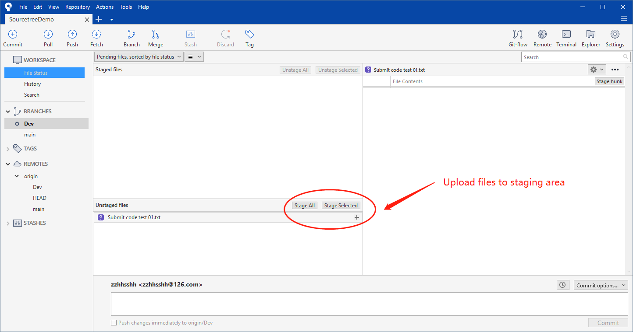

3. Submit the code in the staging area to the local repository:

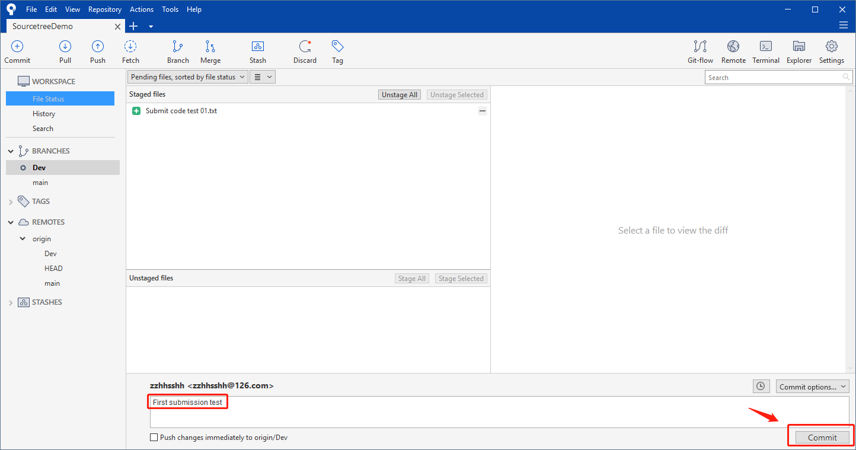

4. Pull the remote code, update the local code repository, and push the local code to the remote repository

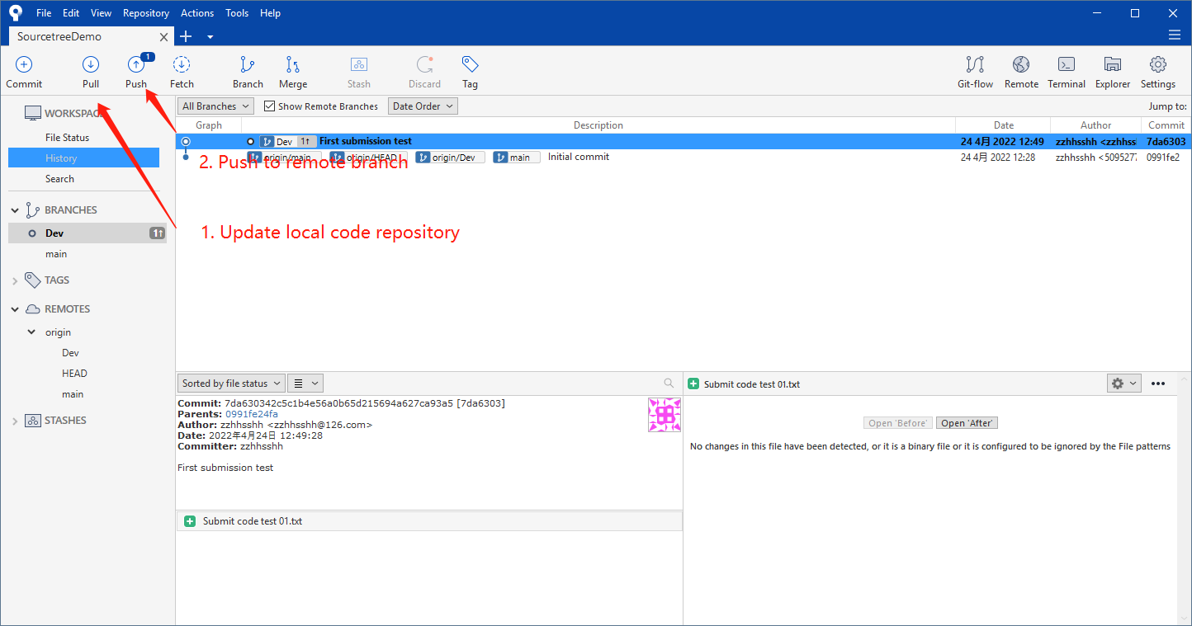

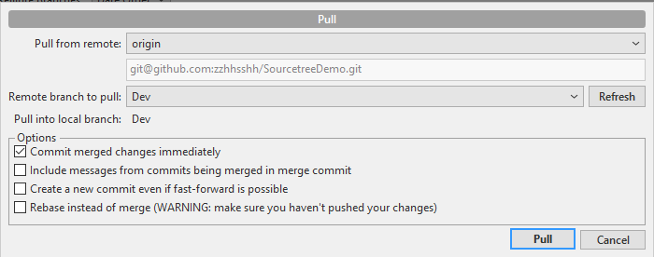

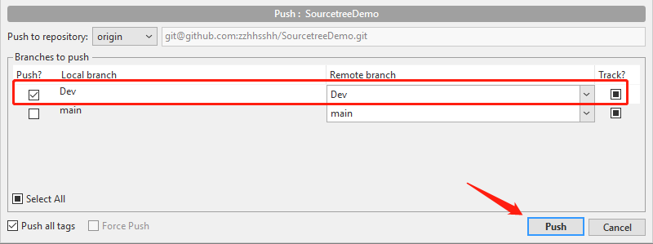

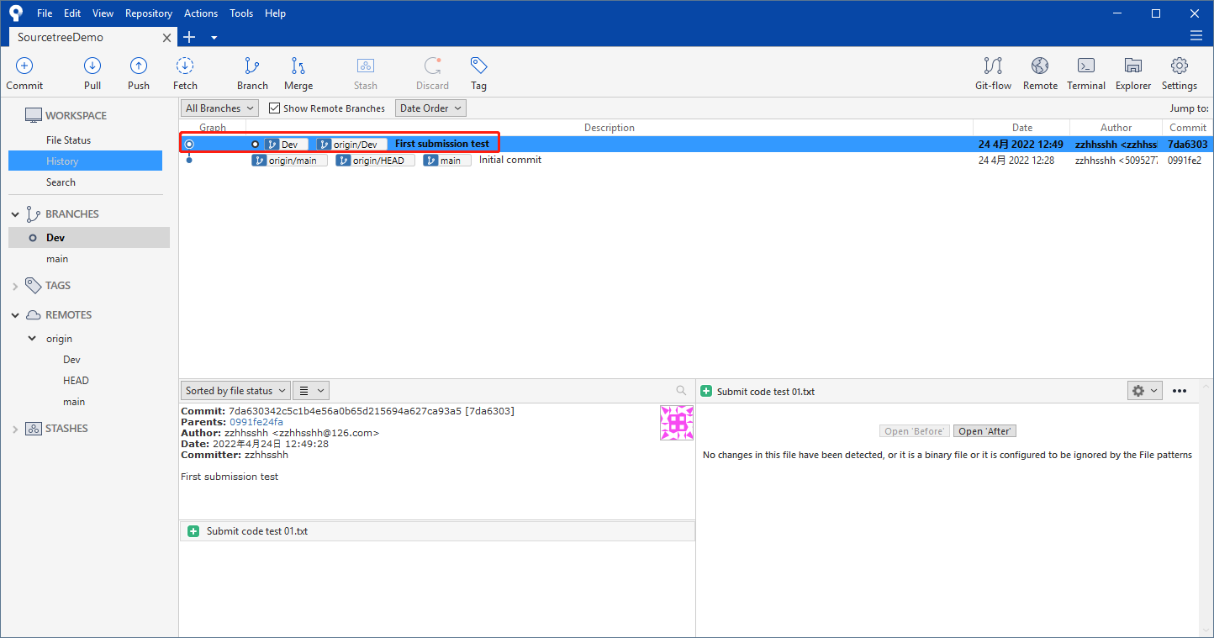

**Sourcetree branch switch, create, merge**

1. branch switch

Double click the corresponding branch to switch.

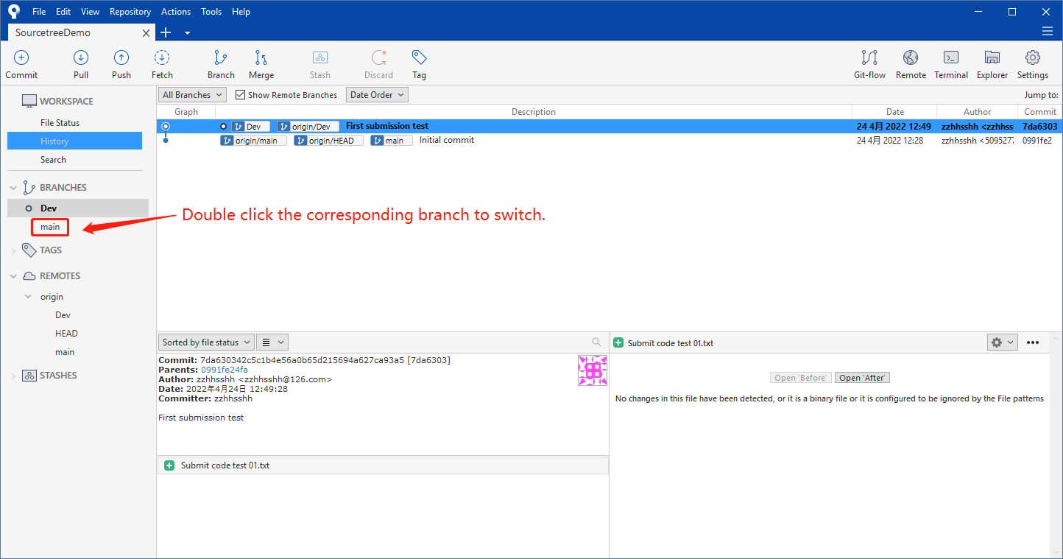

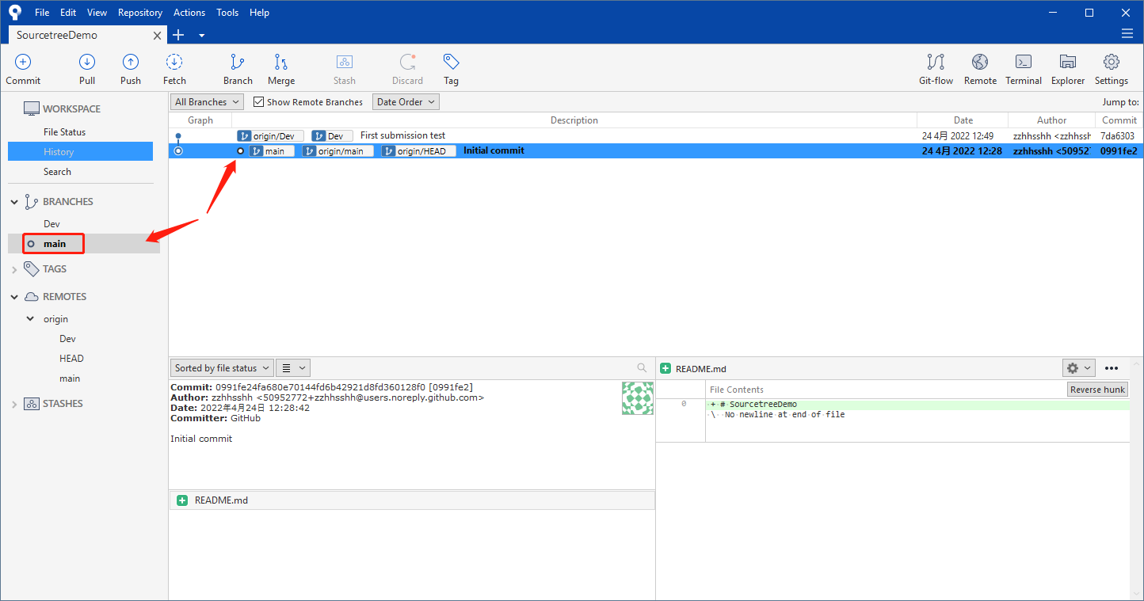

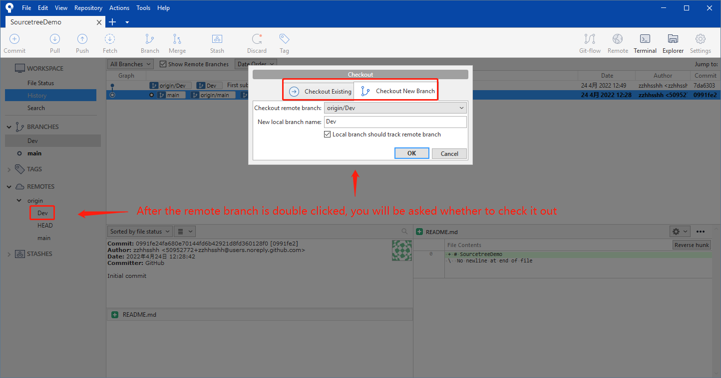

If the remote branch has been checked out before, you will be prompted

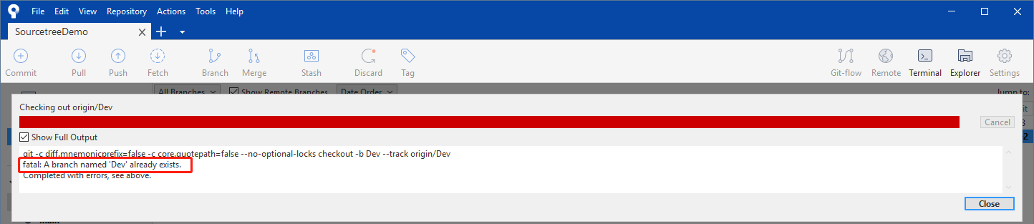

Therefore, if the remote branch has been checked out before, you should select "**Checkout Existing**"

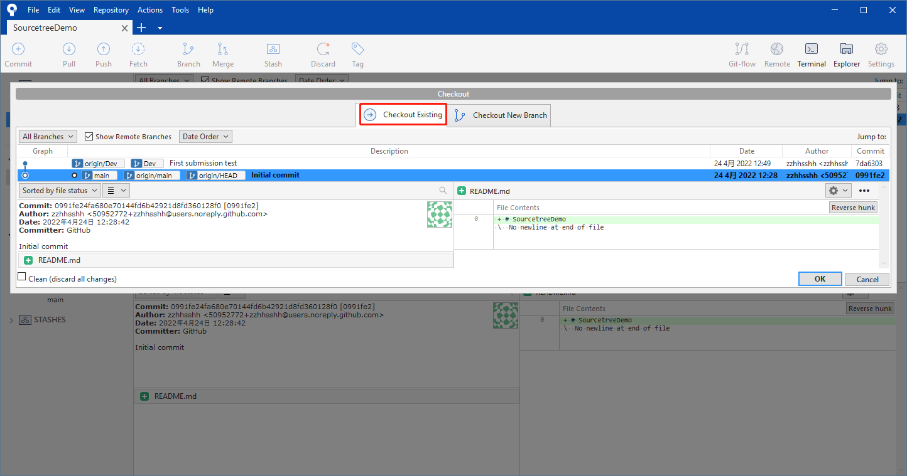

2. Create a new branch

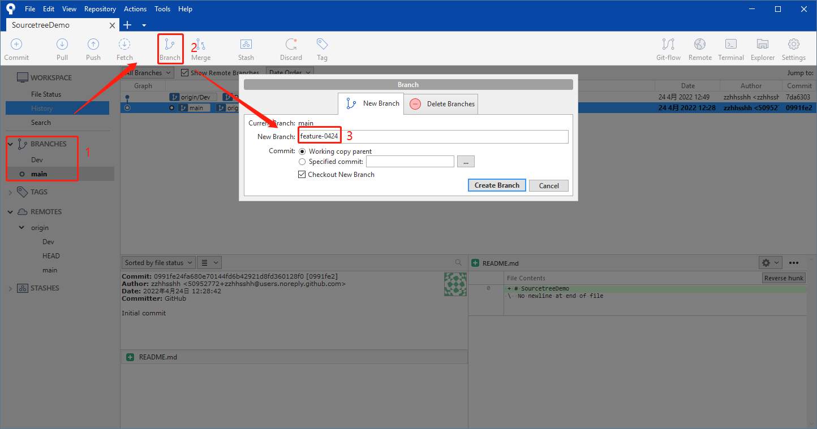

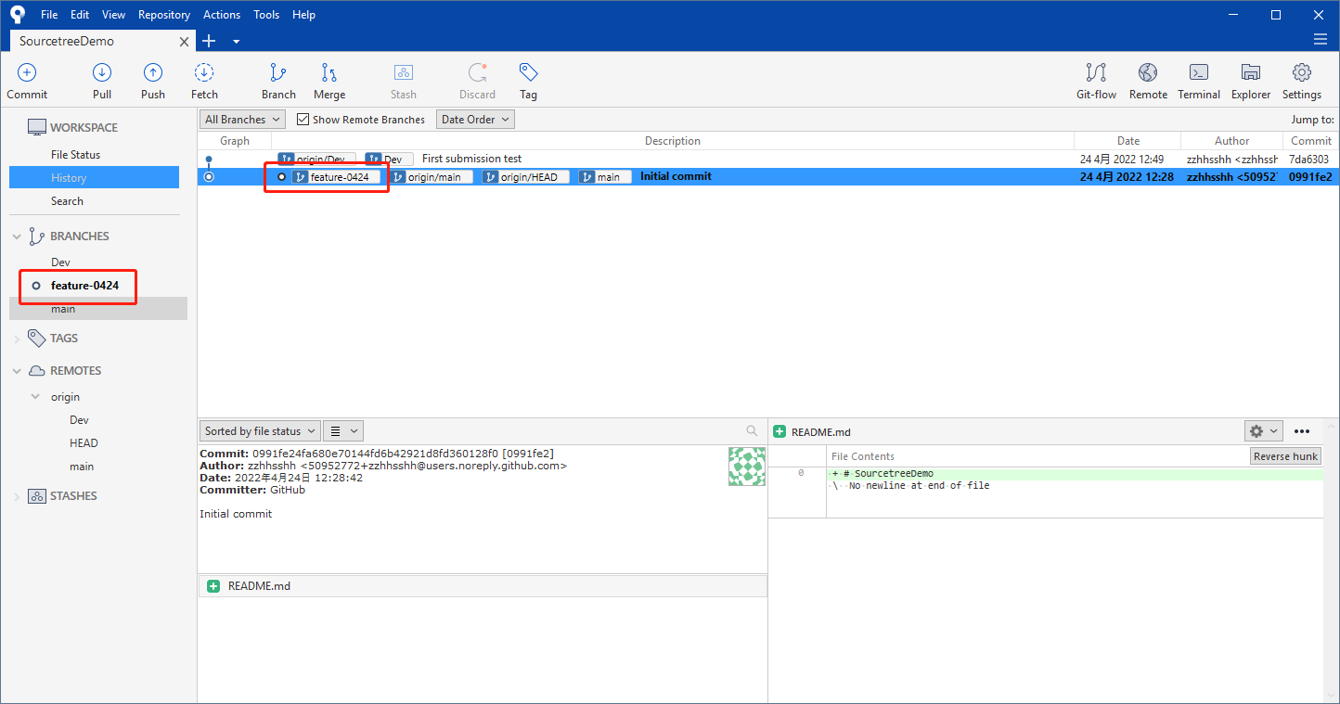

3. Merge branch

Note: before merging branches, we need to pull the corresponding branches to the latest state to avoid overwriting other people's code or losing some important files.

There are usually two ways to merge:

(1) Right click to merge. For example, to merge "feature-0424" into "main", first switch to "main", and then right-click "feature-0424" to select “Merge feature-0424 into current branch”.

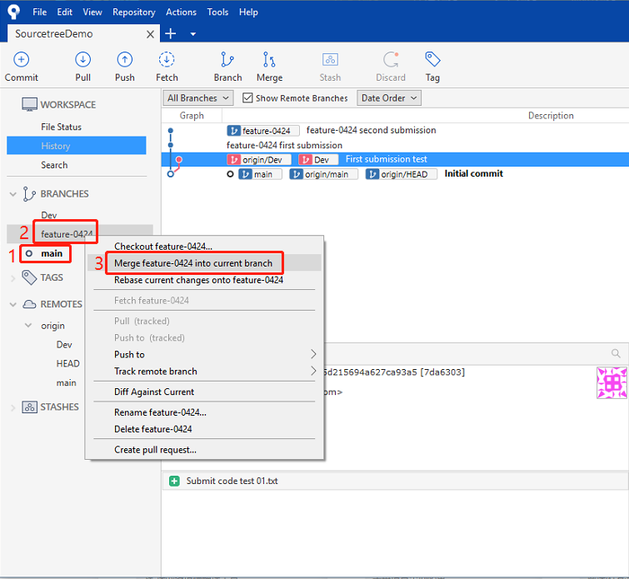

(2) Merge through the merge button. For example, under "main", click the "Merge" button, and a prompt will pop up: "**Pick a commit to merge into your current branch**", select the corresponding node to complete the merge.

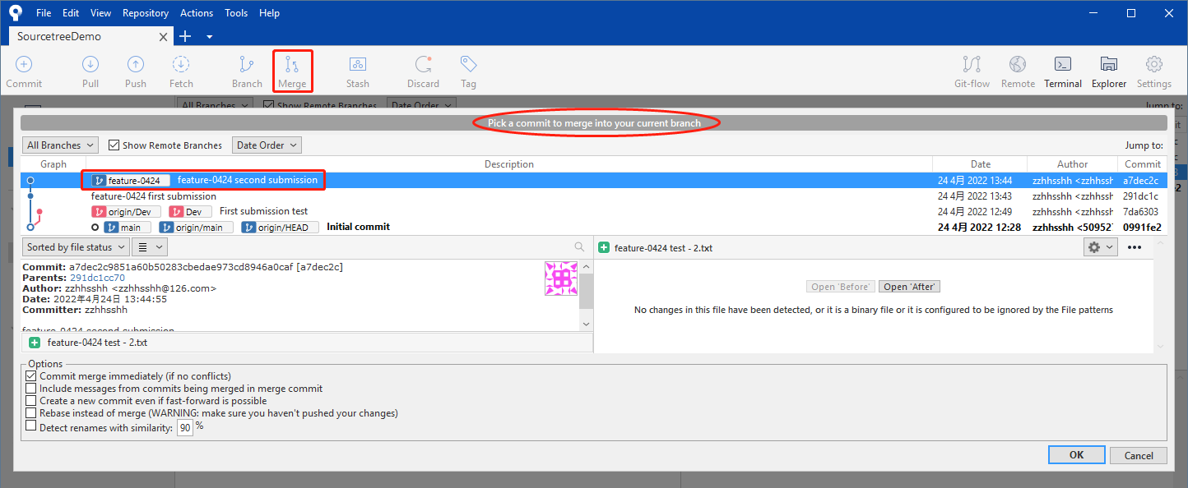

**Sourcetree resolves code conflicts**

There may be code conflicts in many cases. Here we focus on how to solve code conflicts.

Suppose there is a "code conflict testing.txt" under the "main" branch of the local repository, as shown in the figure:

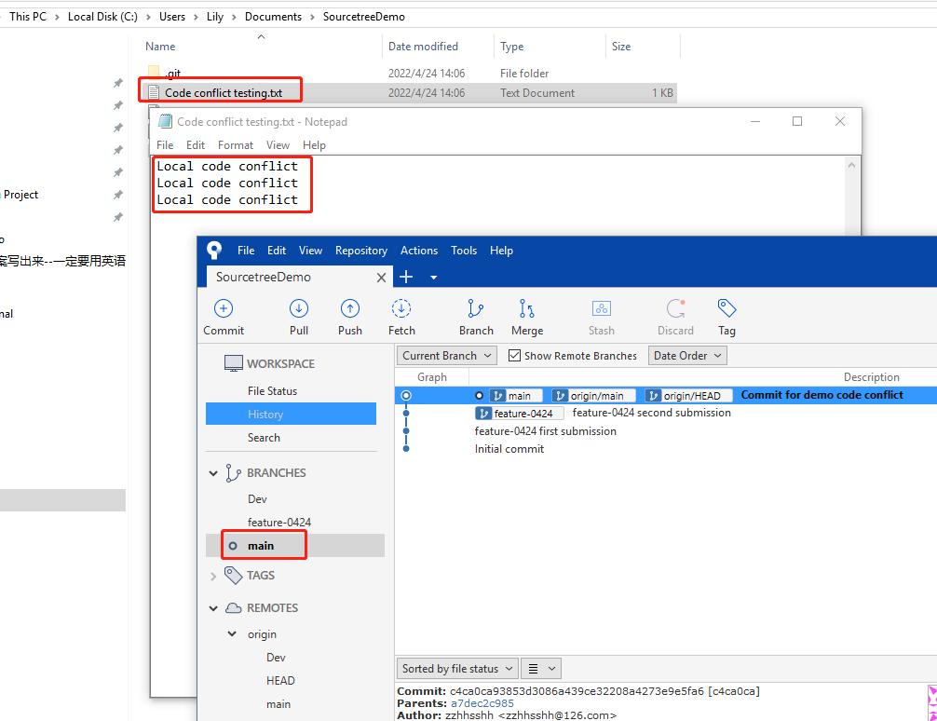

Suppose that there is also a "code conflict testingtxt" under the "main" branch of the remote repository, as shown in the figure:

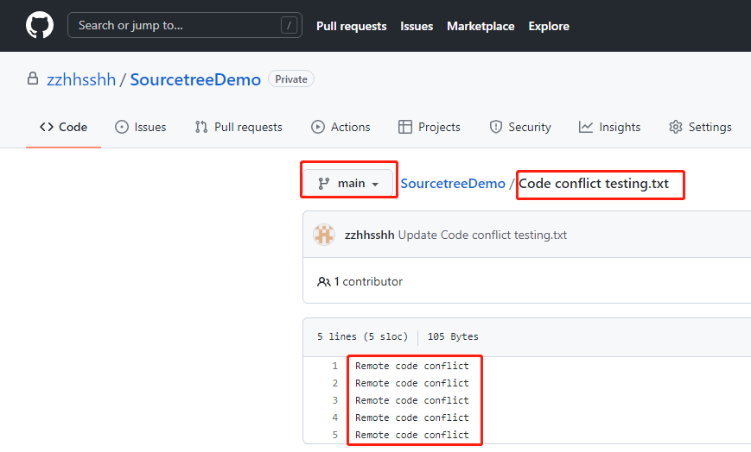

Pull remote "main" to local "main".

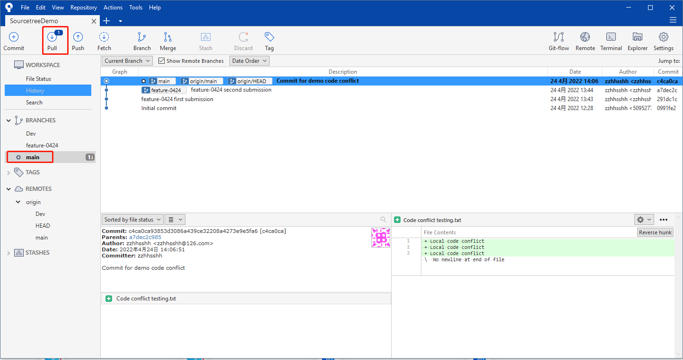

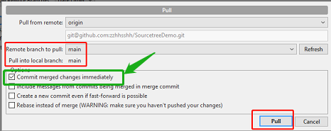

If "**Commit merged changes immediately**" is checked, the content in the local file will be replaced by the remote content:

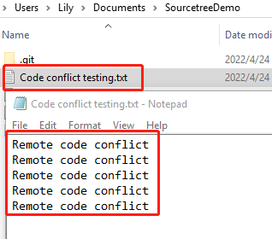

Therefore, try not to select "**Commit merged changes immediately**" when pulling code, otherwise possible code conflicts cannot be found!

Code conflicts are displayed when we do not select "**Commit merged changes immediately**"

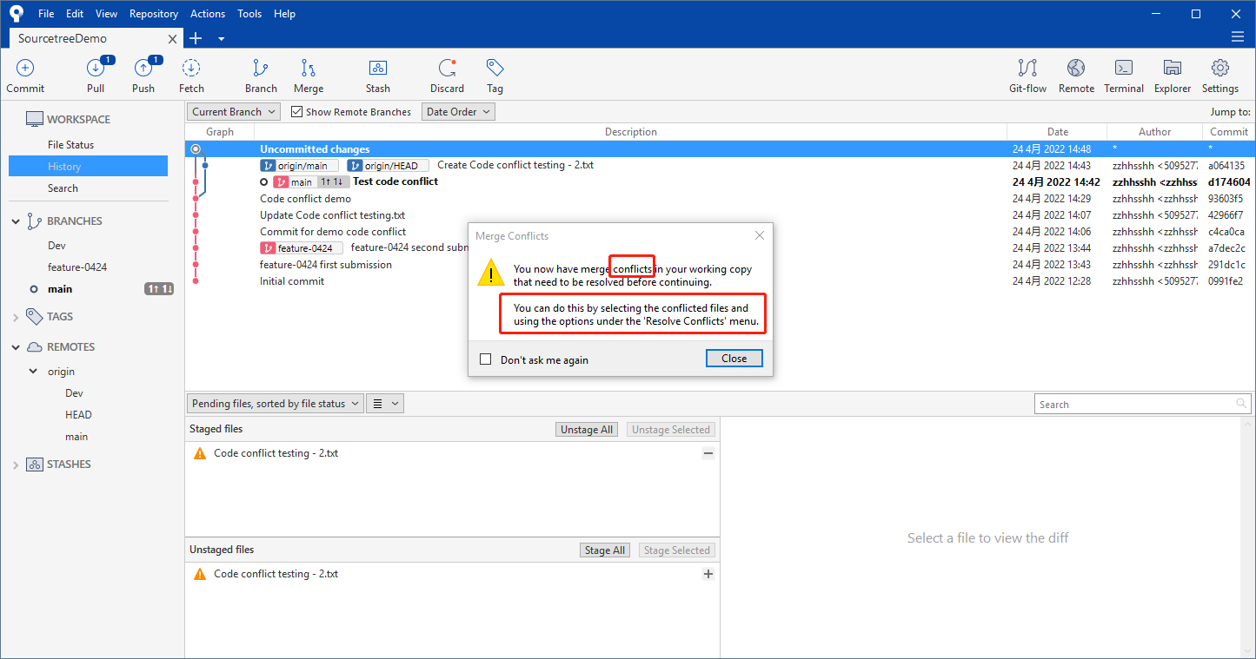

Select the conflict file and you can see the conflict content

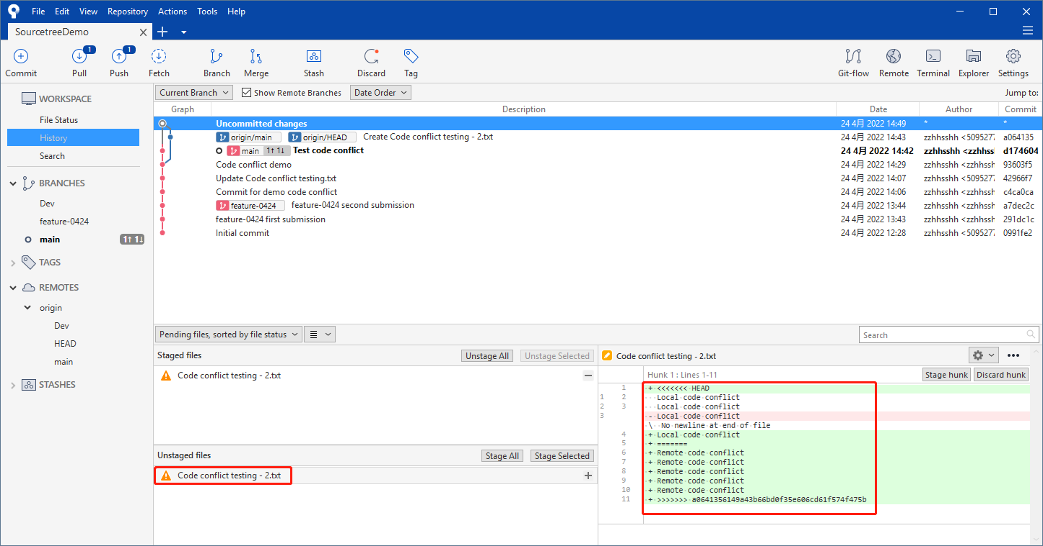

Right click the conflict file and select "**Resolve Conflicts**" to select different conflict solutions

